Hi Blue and Red grapes,

No idea where to start, so I went through Hartanto’s feedback once again and somehow I found out some clues: **“…This module focuses on the emergent effect as results of modeling individual agent in an specific environment…”.**

Ok. Emergent Effect…Obviously we need some independent agents doing its own tasks, but globally accomplishing one common goal. I like the idea from Blue Grape that using coordinates to design our map, so that no cars will drift out of the path. Plus, Red Grape has the experience from last year dealing with the same topic, it’s maybe wiser to still stick with some traffic simulations.

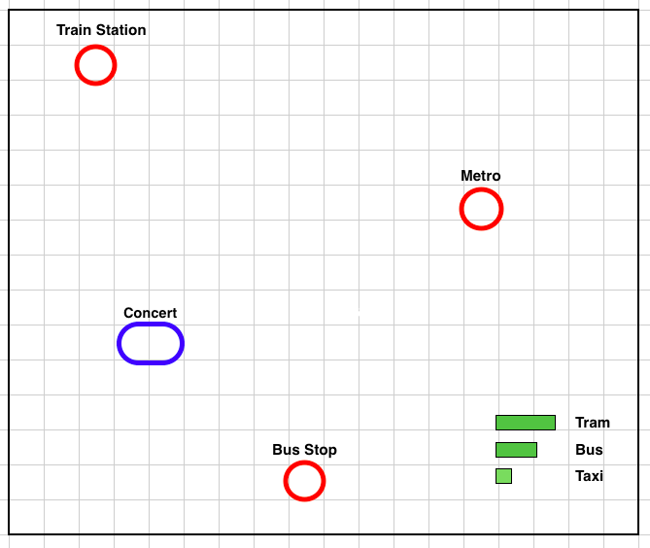Then I notice something else from his email again: **“…with considering the driving behaviours of the simulated agents, e.g., defensive driver, aggressive driver, drunk driver, speedy driver, etc.”** Okay. So that means the agents should have different characteristics, which may not only introduce more variables, but also bring the simulation closer to real world. This reminds me something: In my city, the bus drivers are mostly aggressive, cyclists therefore tend to be defensive, and taxi drivers are in some cases drunk. I realized that these vehicles are all mediums for transporting people…In what kind of event do people need them the most? Say…a concert? My friend once told me that it took him hours to go home after a concert in new year’s eve, as too many people are trying to go on the same way. Hmm…This might be a good start.

Here is how I imagine our project:

In the beginning of the simulation, user is required to enter the number of audiences in the concert. In this example, 1000. The concert, called TGGC (The Grate Grape Concert), is held somewhere in the city center. Public transportations like taxis, trams and busses are roaming on the streets (driving on the line), transporting people from TGGC to Bus stop/Bahnhof/U-Bahn.

The properties of vehicles are listed below:

|  |  |  |  |  |  |
| --- | --- | --- | --- | --- | --- |
| Transportation | Route | Speed | Capacity | Amount | Destination |
| Tram | Fixed | Slow | 50 | Few | Bahnhof |
| Bus | Fixed/Random | Decent | 30 | Some | Bus Stop/U-Bahn/Bahnhof |
| Taxi | Random | Fast | 4 | Many | Random coordinates |

The **Trams (defensive)** follow one pre-defined route (not a straight line but a bit winding), sending audiences only to Train Station.

The **Busses (drunk)** drives basically on one fixed paths (also winding and pre-defined) to either Bus Stop or U-Bahn, yet the driver sometimes (10% chance?) goes to the wrong destination and has to start over again.

The **Taxi (aggressive)** will take the shortest path to random coordinates (assigned by passenger) and then turn back to TGGC.

The simulation starts when the number of audience is entered, and ends when the number of audience equals 0. It’s assumed to be okay that the audiences are willing to take any of the three transportations. Since Tram has only one destination and Taxi’s destination is random coordinates, the destination of Bus is randomly chosen to be either Bus stop/U-Bahn/Bh when depart from TGGC. As mentioned above, with small probability the drunk bus driver will choose the wrong destination and has to start over again. All the transportation will depart from TGGC and return to the same spot after the audiences are sent to the destination.

Of course, the collision avoidance has to be taken into account. This means that the vehicles has to stop at the junction if other transportation is approaching. When two kinds of transportation meet at the crossroad, the priority to have the way is suggested to be TRAM > BUS > TAXI.

Now, the unpredictable events (variables) are

1. Random paths driven by the taxi due to randomly generated destination.
2. Bus driver will take the wrong route (e.g. Will he drive wrong way more than once?)
3. Number of audiences entered by user

These uncertainties will make sure that the collision avoidance (or the event to give way) will take place at different crossroads at each simulation even with the same number of audiences entered. At the end of simulation, time spent/number of collision avoidance should be displayed.

More details/Rules are to be described/defined…

**Conclusion**

I hope you all understand what I am trying to describe. And I also hope this will meet the requirements from two professors as our simulation is no longer networked, driving behavior included, a little bit physics (velocity) involved and most importantly, has no strange buzz word. Please comment on this idea as soon as you have any. We might need to discuss and further make a formal expose out of it before lecture on Monday.

Cheers,

White Grape